**Glasgow University Sports Association**

**Complaints Procedure Handbook**

**If you are unsure about any parts of this document, please get in touch with the GUSA President (**[**gusa-president@glasgow.ac.uk**](mailto:gusa-president@glasgow.ac.uk)**) or Sport Development Manager (SDM) (**[**jenny.beedie@glasgow.ac.uk**](mailto:jenny.beedie@glasgow.ac.uk)**).**

**Terminology:**

* **Reporting Student**: The student lodging a complaint.
* **Responding Student**: The student being complained about.
* **Non-Academic Misconduct**: Behaviour which falls short of the high standard of behaviour expected of students, in a context outside of academic study.
* **Student Conduct Team**: The team responsible for investigating student misconduct (<https://www.gla.ac.uk/myglasgow/studentconduct/>).
* **Safeguarding Team**: <https://www.gla.ac.uk/myglasgow/sexual-violence-harassment-support/students/safeguardingteam/>

**This handbook deals with complaints only. If you are concerned about the mental health or wellbeing of a member, you should get in touch with the Safeguarding Team via email at** [**safeguardingteam@glasgow.ac.uk**](mailto:safeguardingteam@glasgow.ac.uk)**.**

|  |  |
| --- | --- |
| **Contents** | |
| Responsibility | Page 2 |
| Complaints Procedure Flow Chart | Page 4 |
| Complaints Process | Page 5 |
| What Welfare Resources Are Available To Students? | Page 7 |

Updated February 2025

**RESPONSIBILITY**

**It is the Welfare Officer and CTS’s role to:**

* Ensure the immediate safety of the student, referring them to Safeguarding, the police or using the SafeZone App if necessary.
* Ensure that confidentiality is maintained at all times, with information only being divulged on a strictly need-to-know basis.
* Ensure that both the Reporting and Responding Students are supported throughout any complaints and signposting them to relevant support services if required.
* Create a safe space for reporting within your club and make sure reporting procedures are known and followed.
* Conduct internal disciplinary meetings if required, ensuring proper procedures are followed and notes are kept.
* Refer any serious or formal complaints to the GUSA President/SDM.
* Report any patterns of behaviour by students in your club to GUSA President/SDM to allow appropriate training and campaigns to be developed.

**It is not your role to:**

* Assign guilt/blame.
* Confront the accused.

You should consult with the GUSA President/SDM on any formal complaints that arise **before** taking disciplinary action against a student. If required, the GUSA President/SDM can give advice on temporarily suspending a club member, but **this should not be done without prior consultation with the GUSA President/SDM**.

**GUSA only deals with incidents which have occurred between two GUSA club members at a GUSA club event (eg. Training sessions/events/socials).** In the following instances, your report should be made directly to the Student Conduct Team by emailing [student-conduct@glasgow.ac.uk:](mailto:student-conduct@glasgow.ac.uk)

* An incident during a personal/non-club get-together or in people’s free time, even if both parties are GUSA club members.
* An incident between a GUSA club member and a non-GUSA club member.

You can contact the GUSA President/SDM at any point for advice. You can also contact the Student Conduct Team or Safeguarding Team at any time.

The table below is a guide to help outline who to contact – if in doubt, please contact the GUSA President/SDM for advice.

|  |  |
| --- | --- |
| **Handle internally** | **Refer to GUSA President and Sport Development Manager** |
| One-off behavioural/bullying issues | Repeated or high-level behavioural/bullying issues |
| Club conflicts or committee members not fulfilling their responsibilities | Criminal behaviour/GBV |
| Minor club code of conduct breaches | GUSA code of conduct breaches or more serious club code of conduct breaches |
|  | Repeated/ongoing club conflicts or failure to fulfil committee responsibilities |
|  | Any formal complaints that are intended to be filed |
|  | Issues involving external parties |

If you believe there is a risk to a student in your club due to a non-club related incident, then you should contact GUSA President/Sport Development Manager for advice.

If an incident occurs in UofG Sport facilities during a training session and requires immediate action, it should be reported to a Duty Manager (who you can ask for at reception). The “Ask for Angela” initiative is also in place within UofG Sport facilities.

If you live in a university residence, you can raise issues with a Living Support Assistant.

**GUSA REPORTING FLOW CHART**

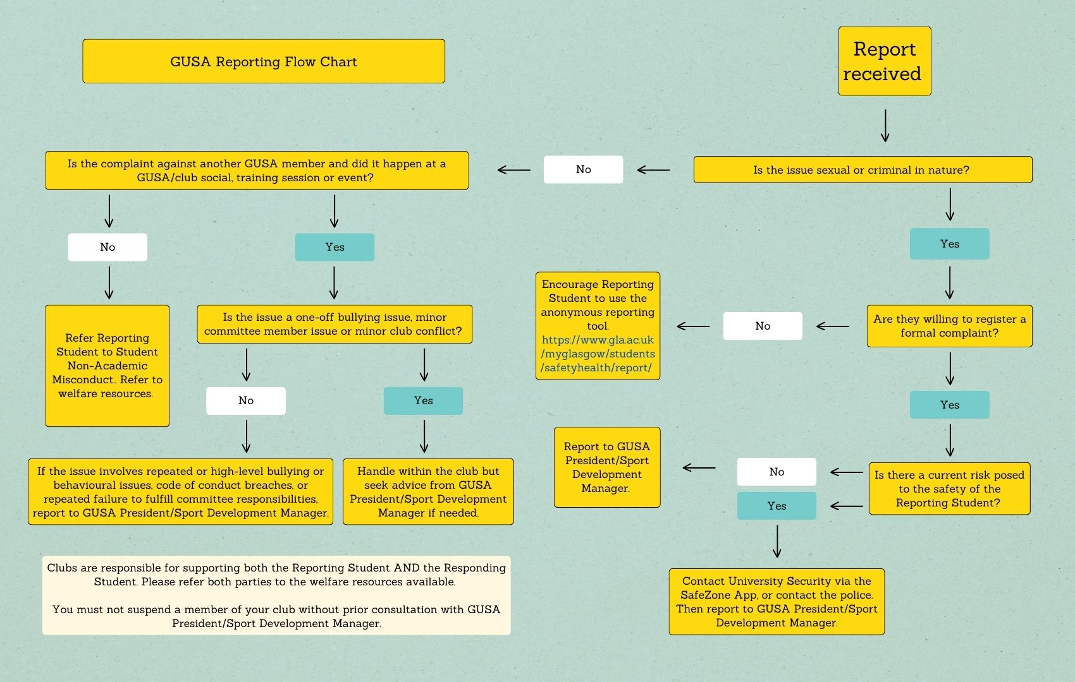

**COMPLAINTS PROCESS**

**How to handle a complaint internally**

* Collect a written statement from the Reporting Student.
* Ensure the Reporting Student is aware that you will need to tell the Responding Student who has reported them and why.
* Hold a meeting with the Responding Student ensuring that 2 committee members are present, and the Responding Student has been provided with an opportunity to bring someone for support.
* Present the complaint to the Responding Student and allow them to respond. **Make sure notes are taken at this meeting.**
* Depending on the nature of the complaint, you could impose a sanction or warning at this stage, or you may wish to discuss and inform the Responding Student afterwards. **You must consult the GUSA President/Sport Development Manager before taking more serious action such as suspension from the club.**
* Ensure the Responding Student has seen all information, and ensure that confidentiality is maintained, only informing those who need to be informed.

**Making a report to GUSA:**

If it has been concluded that the issue cannot be handled internally, the CTS/Welfare Convenor should present the opportunity to the Reporting Student to formally register a complaint to GUSA.

To do this, you must have:

* A written statement from the reporting student via email by them or done on their behalf with permission.
* Corroborating witness(es).
* The Reporting Student’s name attached to the complaint.

The Reporting Student should be aware that the Responding Student will be informed of who has made the complaint against them and will see the complaint that has been made. If a student wishes to submit an anonymous complaint, they cannot do this to GUSA, but they can report it through the university’s anonymous reporting tool (<https://www.gla.ac.uk/myglasgow/students/safetyhealth/report/>), but **no formal action or investigation will come from an anonymous complaint.**

All efforts will be made to keep the complaint and any associated meetings confidential. We will ensure that your personal data is held securely. Information will only be disclosed to the necessary official parties. At a club level, this information is being brought to you as a trusted member of committee. Any information disclosed to you should not be shared with anyone other than the relevant professional parties.

It is important to remind the Reporting Student that:

* They have control of the process
  + At any time after they submit a report or official complaint, they can decide not to further pursue the matter.
  + No issues should be acted upon or result in action taken without the Reporting Student being consulted first.

**When not to report to GUSA:**

We only deal with incidents which have occurred between two GUSA club members at a GUSA club event (eg. Training sessions/events/socials).

In the following instances, your report should be made directly to the Student Conduct Team by emailing [student-conduct@glasgow.ac.uk:](mailto:student-conduct@glasgow.ac.uk)

* An incident during a personal/non-club get-together or in people’s free time, even if both parties are GUSA club members.
* An incident between a GUSA club member and a non-GUSA club member.

**How GUSA handles reports:**

If a complaint comes to us, the GUSA President and Sport Development Manager will take the following steps:

1. Meet with the Reporting Student, gathering what has occurred and what outcome is sought.
   1. Note: Anything of a sexual/criminal nature will be passed to the Student Conduct Team at this point.
   2. The Reporting Student will be provided with the opportunity to bring someone to the meeting if they choose to.
2. Meet with the Responding Student, inform them of the details of the complaint, and hear their account. The Responding Student will be provided with the opportunity to bring someone to the meeting if they choose to.
   1. At this point the Responding Student will either recognise the allegations or not:
      1. If the Responding Student recognises the allegations, we will work with them to rectify the situation, through an apology and appropriate sanction if deemed necessary by the GUSA President and Sports Development Manager.
      2. If the Responding Student does not recognise the allegations, and a clear path to resolution does not appear clear, we will then pass this to the Student Conduct Team.
3. Provide the Reporting Student with an update and outcome.

Reports are stored by GUSA for seven years in line with GDPR regulations.

**WHAT WELFARE RESOURCES ARE AVAILABLE TO STUDENTS?**

Here is the link to some of the support resources (available to BOTH the Reporting Student, and the Responding Student): <https://www.gla.ac.uk/myglasgow/students/safetyhealth/> - it is your responsibility to direct both/all parties involved to these resources and offer them support.

The SRC provides a confidential advisory service which can be accessed in person or online through this link: <https://www.glasgowunisrc.org/advice/about/.>

**Emergency/Crisis or threat to life:**

* Immediately call 999
* Notify Campus Security: Gilmorehill 0141 330 4444; Garscube 0141 330 2222, or via the SafeZone App

**Concerned about your own or someone else’s mental health:**

* University Crisis Team - Call: +44 (0) 141 330 4444 (ext. 4444)
* The Samaritans - Call: 116 123
* Breathing Space Helpline - Call: 0800 83 85 87

**For those suffering as a victim of GBV:**

* Glasgow and Clyde Rape Crisis - <https://www.glasgowclyderapecrisis.org.uk/get-in-touch/> for more information on their drop-in services or how to get in touch.
* Call their Glasgow and Clyde Crisis Helpline at – 08088 000 014

**For support with a disability or a chronic condition:**

* University Disability Service <https://www.gla.ac.uk/myglasgow/disability/>
* GUSA Disabled Students’ Accessibility Form (For any student with a mental, sensory and/or physical disability who is wanting to join a GUSA Sport's club and is needing adaptations or who is unsure of how they can participate within GUSA): <https://docs.google.com/forms/d/1bPllQ5ryuREGid8R9hq-F_FsTTJyEkpxVFonN5SMJkA/viewform?ts=6656078a&edit_requested=true>

**Physical Health:**

* To access immediate medical help or advice if your condition is NOT life threatening - call NHS 24: 111 (calls are free).